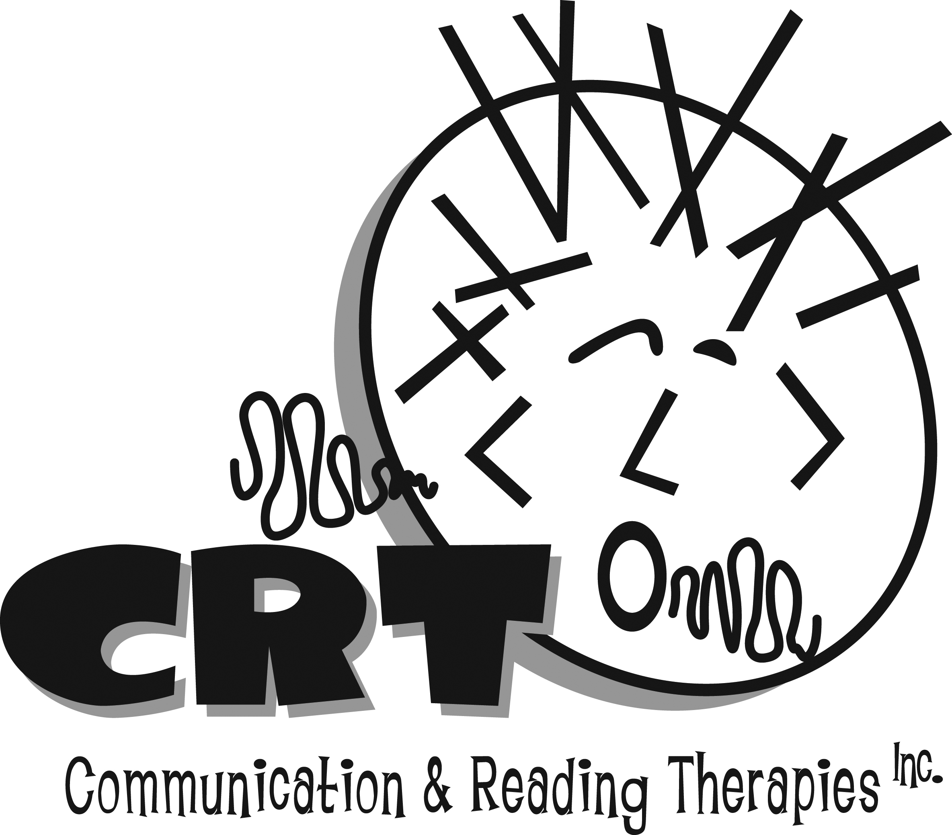
www.communicationandreading.com
Speech-Language Pathologists
300 Vestavia Parkway, Suite 2300
Birmingham, AL 35216
(205) 919-0955
info@communicationandreading.com

ACKNOWLEDGEMENT OF RECEIPT OF NOTICE OF PRIVACY PRACTICES

**You may refuse to sign this acknowledgement

I,__________________________________, have received a copy of this office’s Notice of Privacy Practices.

___________________________________
(Please print Child’s/Childrens’ names)

___________________________________
(Signature)

___________________________________
(Date)

For Office Use Only

We attempted to obtain written acknowledgement of receipt of our Notice of Privacy Practices, but acknowledgement could not be obtained because:

❑ Individual refused to sign

❑ Communication barriers prohibited obtaining acknowledgement

❑ An emergency situation prevented us from obtaining acknowledgement

❑ Other (please specify)

