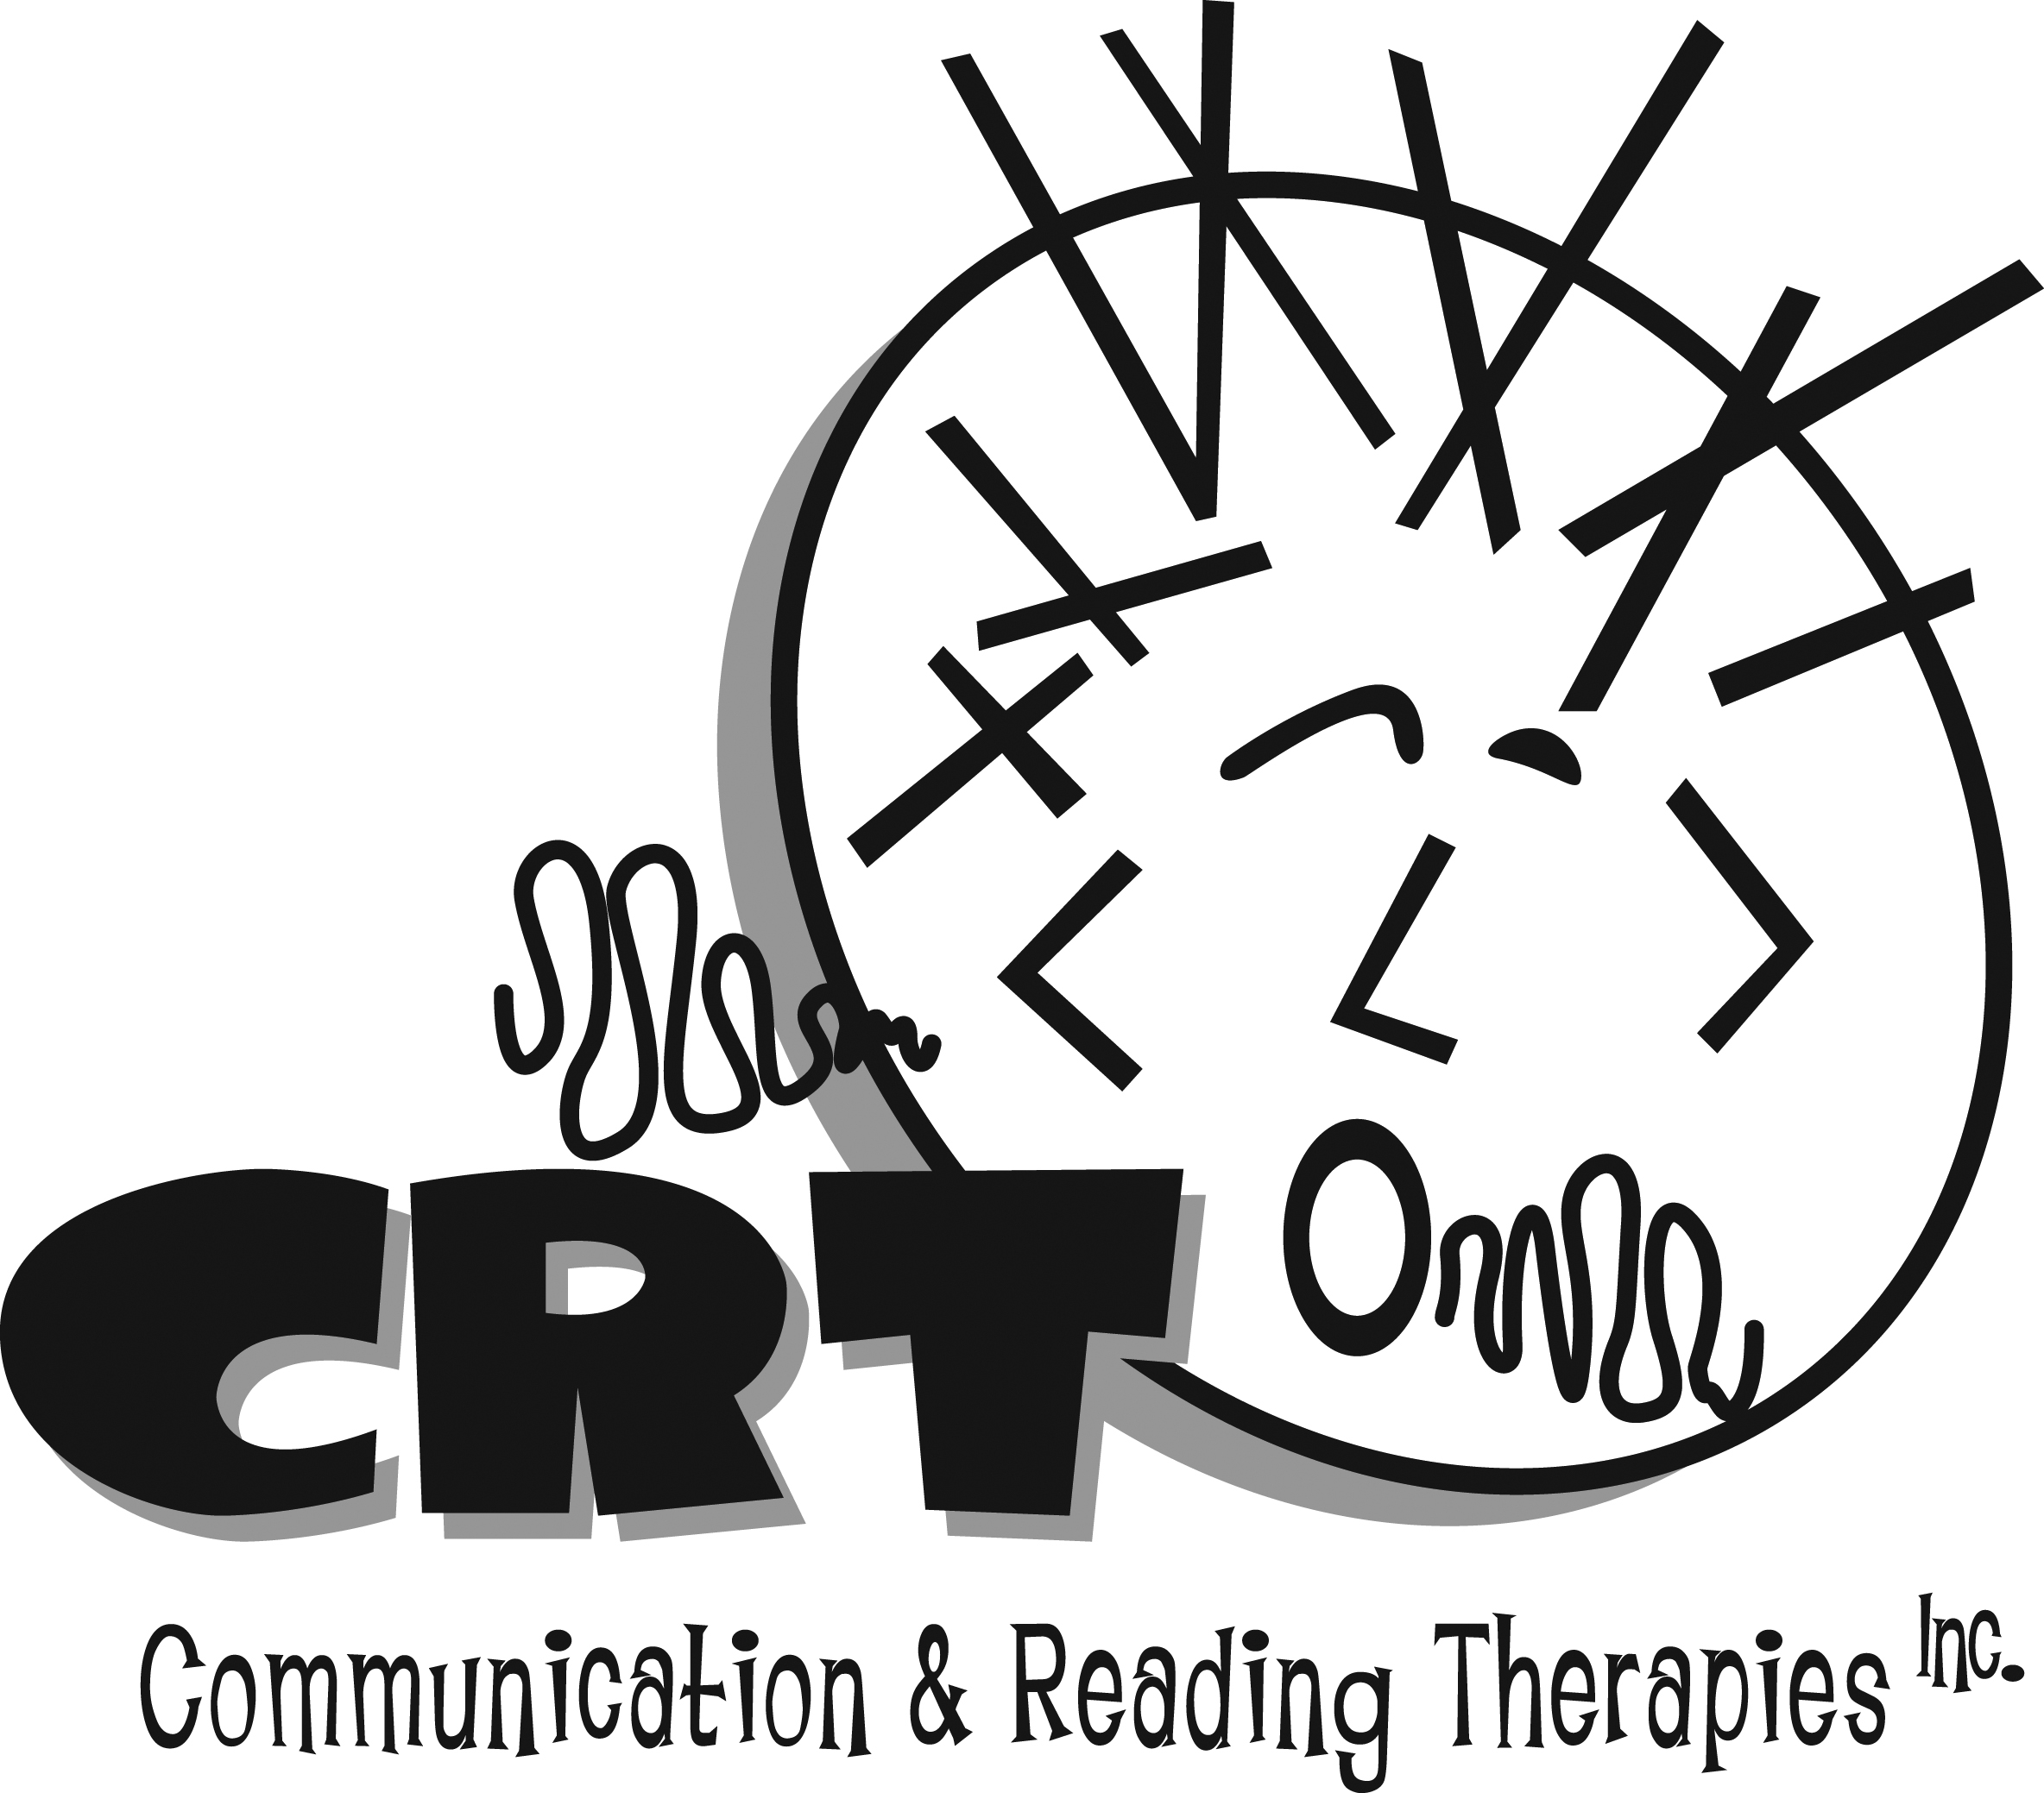
www.communicationandreading.com
Speech-Language Pathologists
300 Vestavia Parkway, Suite 2300
Birmingham, AL 35216
(205) 919-0955
info@communicationandreading.com

1. THE PRIVACY OF YOUR CHILD’S EVALUATION AND TREATMENT PLAN
INFORMATION IS IMPORTANT.
Communication and Reading Therapies (CRT) is committed to respect client privacy and protect confidential client information.
This notice of Privacy Practices describes the ways in which CRT may share your child’s evaluation and treatment plan with others. If you do not understand the terms of this notice, please ask for further clarification. This notice is required under the new healthcare federal privacy law, the Health Insurance Portability and Accountability Act of 1996 (HIPAA).

2. WHO WILL FOLLOW THIS NOTICE
This notice applies to all the CRT records of your child’s evaluation and treatment plan. This notice describes the practices of CRT and its healthcare professionals, as well as other individuals and companies authorized to enter information into your child’s records.

3. CRT’S RESPONSIBILITIES
Evaluation and Treatment plans for your child are privileged information and must be properly safeguarded. CRT will respect the privacy of this privileged information and comply with all applicable privacy laws.

4. You have the right to:
Ask that CRT limit how your child’s evaluation and treatment information is disclosed.
• Request in writing any such restrictions; you may not be able to limit the uses and disclosures required by law.
• Request in writing that your child’s evaluation and treatment information be sent by different means or to different locations such as only to work address, fax instead of mail etc. CRT must agree that your written request is reasonable and they can comply.
• See and receive copies of child’s evaluation and treatment plan. Copies must be requested in writing; there may be charges for copies. If CRT is unable to comply with your request, the reason for not complying with your request will be sent to you in writing.
• Receive a list of the recipients to whom CRT has disclosed your child’s evaluation and treatment information. This request will be in writing. Some restrictions may apply.
• Request in writing that CRT amend your child’s evaluation and treatment information if you feel the information is incomplete or incorrect. If CRT is
unable to comply with your request, the reason for not complying with your request will be sent to you in writing.

5. Examples of how CRT will disclose your child’s evaluation and treatment information.
• Your child’s evaluation and treatment information may be shared with other healthcare professionals to determine the best treatment plan.
• CRT will disclose your child’s evaluation and treatment information on bills sent to you or your insurance company.
• CRT may disclose evaluation and treatment information when you are contacted for an appointment or follow-up after a visit.
• CRT may disclose evaluation and treatment information when required to so by federal, state or local law, including child abuse or neglect reporting.
• CRT will disclose evaluation and treatment information to business partners such as an accounting firm who does billing. These business partners must agree in writing to respect the confidentiality of this information.
• CRT may disclose evaluation and treatment information for law enforcement purposes or litigation in response to a valid subpoena or other court order.
• If you believe your child’s privacy rights have been violated, please contact Laura Promer, President, Communication and Reading Therapies, 2300 Vestavia Parkway, Birmingham, AL, 35216 at laurapromer@charter.net or 205-870-4241.

